**Export and Import DRS rules and VM/Host groups**

**Install DRSRule module:**

1. Copy the Zip file (DRSRule-master.zip) from \\nashprd102v8\CPS_Compute\Scripts extract to the local folder

2. Open PowerCLI and change the directory to the extracted folder.

3. Run the “DownloadLatest.ps1” script (This will download and install the DRSRule PowerShell module)

Note: Module installation is a onetime process. It’s not required to run the script again on the same machine.

**Export DRS Rules:**

1. Copy the PowerShell script “export_drs_rues_groups_json.ps1” to local folder

2. Run the script on PowerCLI and input the required values.

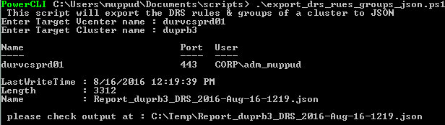

3. This script will export the DRS rules and VM/Host groups of specified cluster to a JSON file on C:\TEMP folder.

**Import DRS Rules:**

1. Copy the script “ import_drs_rues_groups_json.ps1” to local folder and Run the script on PowerCLI.
2. The script will prompt for the vcenter name and the credentials to which the DRS rules to be imported.
3. Specify the JSON file location of the cluster to be imported.

